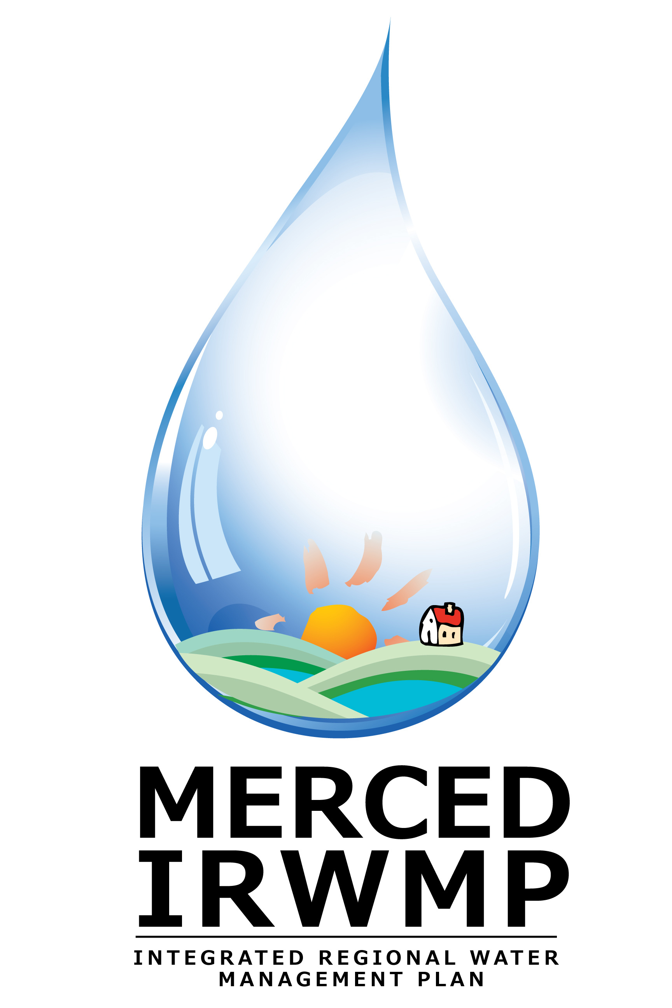
Merced Integrated Regional Water Management Plan

The Merced Region is undertaking development of an Integrated Regional Water Management (IRWM) Plan. This effort was initiated by the Merced Area Groundwater Pool Interests (MAGPI), which currently serves as an interim Regional Water Management Group (RWMG) responsible for developing the IRWM Plan. The Region has received a grant from the California Department of Water Resources (DWR) to prepare a plan that meets statewide IRWM Plan standards. Preparing and adopting a Plan that complies with these standards will make the Region eligible to secure additional funding for implementation of high priority water resources projects. As such, the Plan will ultimately need to be adopted by the governing bodies of the RWMG agencies.
MAGPI Member Agencies:
City of Merced City of Atwater
City of Livingston County of Merced
Merquin County Water District Le Grand/Athlone Water District
Merced Irrigation District East Merced RCD
Stevinson Water District Meadowbrook Water Company
Black Rascal Water District Planada Community Services District
Turner Island Water District Lone Tree Mutual Water Company
Winton Water & Sanitary District Le Grand Community Services District

The Merced IRWM regional boundary is defined by the MAGPI boundary, an area slightly larger than the Merced Groundwater Subbasin, covering approximately 521,000 acres. The region is primarily agricultural with urban lands on the San Joaquin Valley floor in the eastern portion of Merced County (east of the San Joaquin River).
This document provides background on the Statewide IRWM Program and the steps the Merced region is taking to develop an IRWM Plan.

Statewide IRWM Program
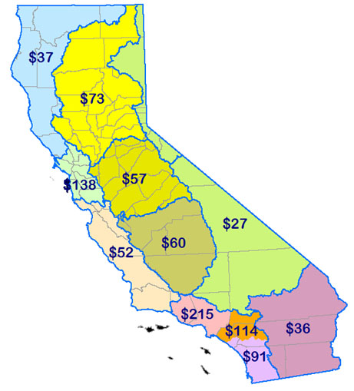
Nearly ten years ago, the State of California embarked on a new venture to implement integrated water management planning at the regional level, known as IRWM planning. Over time, this program has evolved into a major water resource planning framework implemented statewide, and the California Water Plan cites IRWM as a new paradigm for water planning. Through the IRWM program, the State of California has encouraged collaboration among water supply and wastewater agencies, flood control and stormwater protection districts, resource and regulatory agencies, non-governmental organizations, local governments, and volunteer groups to enhance integration in water management planning – all at the regional level. Through this planning framework, the efforts of individual entities and communities are combined to leverage resources and meet multiple water resource management objectives.
Merced
IRWM Region
The intent of the initial IRWM Program was to promote a new model for water management by encouraging integrated regional strategies for management of water resources. The State supports integrated regional strategies by provide funding, through competitive grants, for projects that protect communities from drought, protect and improve water quality, and improve local water security by reducing dependence on water imported from the Sacramento-San Joaquin Bay-Delta and Colorado River. Funding for integrated planning and project implementation at the regional level was a major component of the program, providing incentive for regions to engage in this new form of planning. Plans developed through the program were required to address a series of requirements, including preparation by three or more entities with water management authority; identification of regional water management objectives and priorities spanning multiple water management functional areas; integration of water management strategies to achieve regional objectives; and engagement of the public – including disadvantaged and environmental justice (DAC and EJ) communities – in robust stakeholder involvement efforts.

IRWM Program Standards and Guidelines
In November 2004, DWR and the State Water Resources Control Board (SWRCB) jointly released guidelines for the new IRWM Planning program. Proposition 50, the Water Security, Clean Drinking Water, Coastal and Beach Protection Act of 2002, made $500 million available to fund the program.
Merced IRWMP Outline
- Introduction
- Region Description
- Governance
- Objectives
- Resource Management Strategies
- Project Review Process
- Impacts and Benefits
- Plan Performance and Monitoring
- Data Management
- Finance
- Technical Analysis
- Relation to Local Water Planning
- Relation to Local Land Use Planning
- Coordination
- Climate Change
The IRWM Plans developed through Proposition 50 represented the first generation of IRWM planning. Following Proposition 50, an additional $1 billion in funding was made available for IRWM planning and implementation through passage of the Safe Drinking Water, Water Quality and Supply, Flood Control, River and Coastal Protection Bond Act of 2006 (Proposition 84). Development of the Merced IRWM Plan is being funded by a grant received from DWR through Proposition 84 along with matching funds contributed by the City of Merced, the County of Merced, and the Merced Irrigation District (MID). The Plan, when completed, must comply with the IRWM Plan Standards established by DWR in the Proposition 84 & Proposition 1E Integrated Regional Water Management Grant Program Guidelines (August 2010).

What Types of Activities Are Encouraged?
The intent of IRWM is to encourage integrated regional planning strategies for management of water resources. In addition to funding planning efforts to develop Standards-compliant IRWM Plans, Proposition 84 will fund implementation projects that integrate multiple Resource Management Strategies to generate multiple benefits and contribute to the achieving the Region’s water management objectives.
CALIFORNIA WATER PLAN: RESOURCE MANAGEMENT STRATEGIES
Reduce Water Demand  - Agricultural Water Use Efficiency  - Urban Water Use Efficiency  Improve Operational Efficiency & Transfers  - Conveyance  - System Reoperation  - Water Transfers  Increase Water Supply  - Conjunctive Management & Groundwater  - Desalination – Brackish & Seawater  - Precipitation Enhancement  - Recycled Municipal Water  - Surface Storage – Local  Improve Flood Management  - Flood Risk Management | Improve Water Quality  - Drinking Water Treatment & Distribution  - Groundwater/Aquifer Remediation  - Matching Quality to Use  - Pollution Prevention  - Salt & Salinity Management  - Urban Runoff Management  Practice Resource Stewardship  - Agricultural Lands Stewardship  - Economic Incentives  - Ecosystem Restoration  - Forest Management  - Land Use Planning & Management  - Recharge Areas Protection  - Water-Dependent Recreation  - Watershed Management

Stakeholder Participation
The goal of the stakeholder outreach effort is to provide a means for the Merced region’s various entities with interests and/or authority over water management to participate in the IRWM planning effort.
- Merced Regional Advisory Committee (RAC) application process was completed in April 2012
- The RAC will meet monthly in an open forum to guide Plan development
- Four public workshops will be held to receive feedback on the IRWM planning process
- Focused DAC and tribal outreach will be implemented
For more information, please visit www.mercedirwmp.org

